Factor Analysis

Notes
Output Created |  | 28-JUN-2021 13:52:38
Comments
Input | Active Dataset | DataSet43
Input | Filter | <none>
Input | Weight | <none>
Input | Split File | <none>
Input | N of Rows in Working Data File | 92
Missing Value Handling | Definition of Missing | MISSING=EXCLUDE: User-defined missing values are treated as missing.
Missing Value Handling | Cases Used | LISTWISE: Statistics are based on cases with no missing values for any variable used.
Syntax |  | FACTOR  /VARIABLES ZConfirmed ZDeaths ZRecovered  /MISSING LISTWISE  /ANALYSIS ZConfirmed ZDeaths ZRecovered  /PRINT UNIVARIATE INITIAL CORRELATION EXTRACTION ROTATION  /FORMAT SORT  /PLOT EIGEN  /CRITERIA FACTORS(3) ITERATE(25)  /EXTRACTION PC  /CRITERIA ITERATE(25)  /ROTATION VARIMAX  /METHOD=COVARIANCE.
Resources | Processor Time | 00:00:00.22
Resources | Elapsed Time | 00:00:00.21
Resources | Maximum Memory Required | 1984 (1.938K) bytes

[DataSet43]

Descriptive Statistics
 | Mean | Std. Deviation | Analysis N
ZConfirmed | 1.3281801 | .99999943 | 91
ZDeaths | 2.1581701 | .99999963 | 91
ZRecovered | 1.3361702 | 1.00000027 | 91

Correlation Matrix
 |  | ZConfirmed | ZDeaths | ZRecovered
Correlation | ZConfirmed | 1.000 | .937 | .996
Correlation | ZDeaths | .937 | 1.000 | .952
Correlation | ZRecovered | .996 | .952 | 1.000

Communalities
 | Raw |  | Rescaled
 | Initial | Extraction | Initial | Extraction
ZConfirmed | 1.000 | 1.000 | 1.000 | 1.000
ZDeaths | 1.000 | 1.000 | 1.000 | 1.000
ZRecovered | 1.000 | 1.000 | 1.000 | 1.000

Extraction Method: Principal Component Analysis.

Total Variance Explained
 | Component | Initial Eigenvaluesª |  |  | Extraction Sums of Squared Loadings
 | Component | Total | % of Variance | Cumulative % | Total | % of Variance
Raw | 1 | 2.924 | 97.462 | 97.462 | 2.924 | 97.462
Raw | 2 | .074 | 2.456 | 99.917 | .074 | 2.456
Raw | 3 | .002 | .083 | 100.000 | .002 | .083
Rescaled | 1 | 2.924 | 97.462 | 97.462 | 2.924 | 97.462
Rescaled | 2 | .074 | 2.456 | 99.917 | .074 | 2.456
Rescaled | 3 | .002 | .083 | 100.000 | .002 | .083

Total Variance Explained
 | Component | Extraction Sums of Squared Loadingsª | Rotation Sums of Squared Loadings
 | Component | Cumulative % | Total | % of Variance | Cumulative %
Raw | 1 | 97.462 | 1.649 | 54.980 | 54.980
Raw | 2 | 99.917 | 1.348 | 44.930 | 99.910
Raw | 3 | 100.000 | .003 | .090 | 100.000
Rescaled | 1 | 97.462 | 1.649 | 54.980 | 54.980
Rescaled | 2 | 99.917 | 1.348 | 44.930 | 99.910
Rescaled | 3 | 100.000 | .003 | .090 | 100.000

Extraction Method: Principal Component Analysis.
a. When analyzing a covariance matrix, the initial eigenvalues are the same across the raw and rescaled solution.

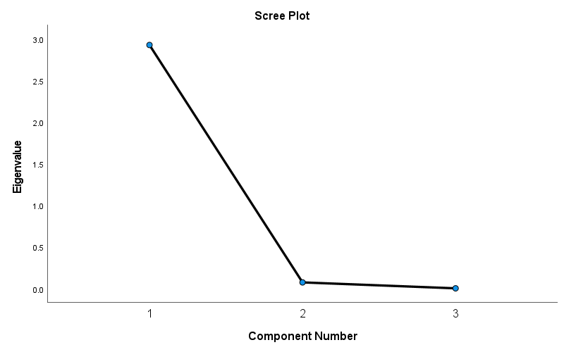

Component Matrixª
 | Raw |  |  | Rescaled
 | Component |  |  | Component
 | 1 | 2 | 3 | 1 | 2 | 3
ZRecovered | .996 | -.085 | -.037 | .996 | -.085 | -.037
ZConfirmed | .991 | -.132 | .033 | .991 | -.132 | .033
ZDeaths | .975 | .221 | .005 | .975 | .221 | .005

Extraction Method: Principal Component Analysis.ª
a. 3 components extracted.

Rotated Component Matrixª
 | Raw |  |  | Rescaled
 | Component |  |  | Component
 | 1 | 2 | 3 | 1 | 2 | 3
ZConfirmed | .825 | .564 | -.024 | .825 | .564 | -.024
ZRecovered | .797 | .602 | .046 | .797 | .602 | .046
ZDeaths | .577 | .817 | .004 | .577 | .817 | .004

Extraction Method: Principal Component Analysis.
Rotation Method: Varimax with Kaiser Normalization.ª
a. Rotation converged in 3 iterations.

Component Transformation Matrix
Component | 1 | 2 | 3
1 | .744 | .669 | .009
2 | -.669 | .744 | .001
3 | .005 | .007 | -1.000

Extraction Method: Principal Component Analysis.
Rotation Method: Varimax with Kaiser Normalization.

